PAYMENT OPTIONS
IN PERSON: You can come to our main office at 1600 19th Avenue to pay your bill.
ACH PAYMENT: Website: patterson.authoritypay.com or 12th of each month (see below)
OR CREDIT/DEBIT CARDS: Website: patterson.authoritypay.com , in person, or by phone.
BY MAIL: Hours: 9:00 a.m. to 4:30 p.m. Monday-Friday. Be sure to allow a few days for payment to reach our office before due date.
DROP BOX: At 1600 19th Avenue, beside municipal office door.

AUTOMATIC CASH TRANSFER (ACH) PAYMENT – Processed the 12th of Each Month Application Form

Name: Phone:

Service Address: Email:

Billing Address: Sewer Acct #:

Financial Institution and Address:

I wish to have my payments withdrawn automatically from the following account: (Enclose a voided check or deposit slip)

Checking Account Savings Account

Bank Account Number:

Bank Routing Number:
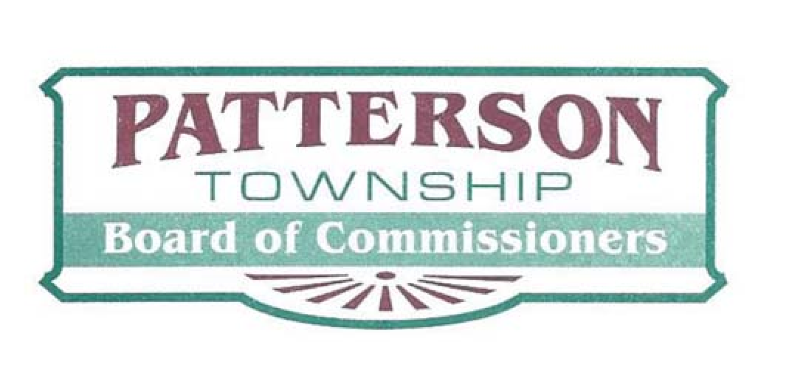
Authorization Agreement for Automatic Cash Transfer – processed the 12th of each month.
I hereby authorize the financial institution I have named on this application to charge the account I have specified for payment on my Patterson Township sewer usage bill.

Signature Date:

Return this signed form by fax, email or mail:
Fax to: (724) 843-8687 | Mail to: Patterson Township
Email to: billing@pattersontwp.com | 1600 19th Avenue
If you have any questions, call (724) 843-8339. | Beaver Falls, PA 15010

